**Experiment 6**

**Draw the DFD to be considered while codding the individual processes or functions.**

**Blood Bank Management System DFD Levels 0, 1 and 2**

**Blood Bank Management System DFD Level 0**

To start with, let us familiarize what is Blood Bank Management System DFD level 0. The Blood Bank Management System DFD level 0 is also known as context diagram. It's supposed to be an abstract view, with the mechanism represented as a single process with external parties. This DFD for the Blood Bank Management System depicts the overall structure as a single bubble. It comes with incoming/outgoing indicators showing input and output data.

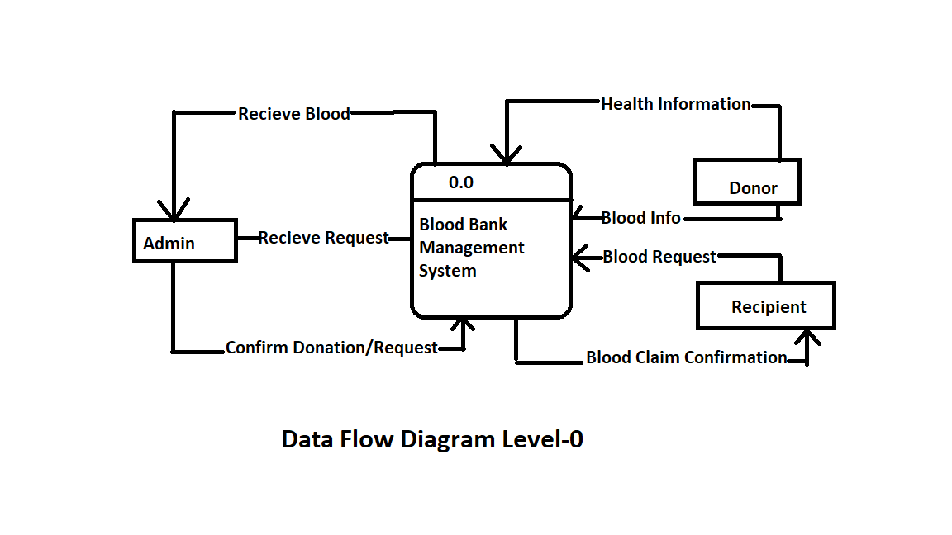

In this data flow diagram, you will see the general process done in Blood Bank Management System monitoring. This will also serve as a guide as you go through the deeper processes of the Blood Bank Management System data flow diagrams. As you see, when you build the levels of data flow diagrams, the connections of the transactions and data also broadens and gets more specific.

**Blood Bank Management System DFD Level 1**

Next to the context diagram is the level 1 data flow diagram. The content of Blood Bank Management System DFD level 1 must be single process node from the context diagram and is broken down into sub processes.

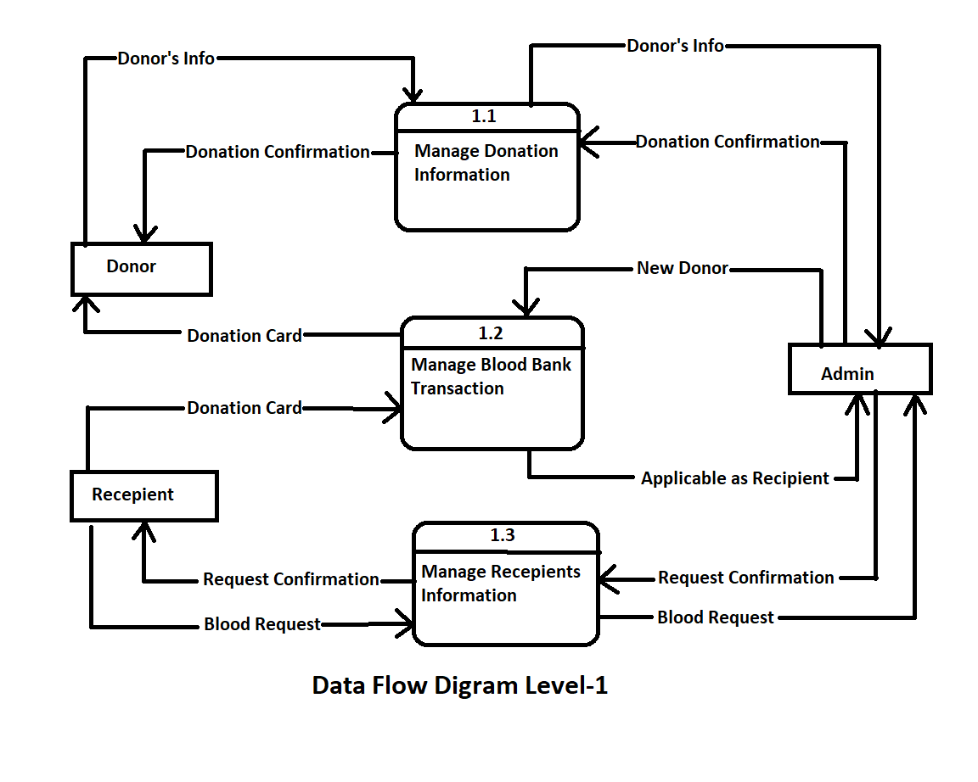

In this level, the system must display or reveal further processing information.

The following are essential data to accommodate:

• Blood Bank Records

• Donors Records

• Donation Records

• Donation Request

• Donors Information

These procedures require information such as record of donors, donations, transactions and blood bank from which served as the bases for the bloodletting or blood bank admin to manage the Blood Bank Management System. This type of data is represented by a data store. With being knowledgeable about the DFD level 1 of the Blood Bank Management System, you will know then its broaden context terms. In addition to that, this may also serve as your reference on how the inputs or data fed on the system. Then you will be also informed about the outputs that the system gives.

These processes shown in the DFD were all based on the concept of Blood Bank Management System.

**Blood Bank Management System Level 2**

After presenting the Blood Bank Management System DFD levels 0 and 1, next to that is level 2.

Here's what you need to consider in creating data flow diagram level 2 for Blood Bank Management System.

• The Level 2 DFD for the system should represent the basic modules as well as data flow between them.

• Since the DFD level 2 is the highest abstraction level, its Blood Bank Management System processes must be detailed that is based on the DFD level 1.

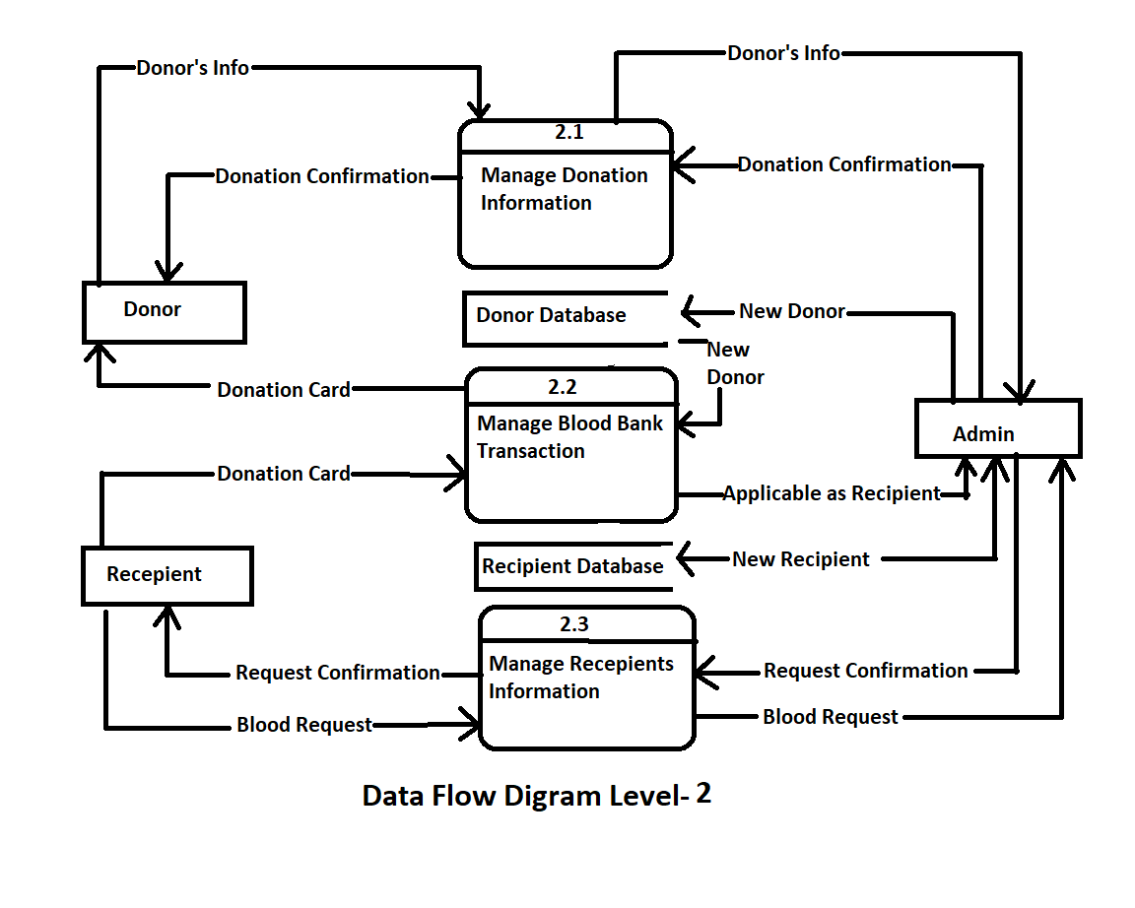

Finally, after figuring the processes given in the system, the user will now have their request being processed.

The Processes that the system should prioritize are as follows:

• Manage Donors' Information

• Manage Blood Donation Information

• Checks Donors' Health Status

• Monitor Donation Transactions

• Manage Blood Donation

Transactions DFD level 2 lets you know the ideas on where does the data inputs goes and inputs comes within the Blood Bank Management System. Considering the the dataflow levels mentioned above, you can determine well the importance of breaking the processes into more specific manner.

The presented level not only shows you the detailed processes of system, but also gives you precise destination of the data that flows in the system.

This DFD will also be your references as you make and design your own project DFD levels 0, 1 and 2.